**AMERICAN INTERNATIONAL**

**UNIVERSITY-BANGLADESH**

**Faculty of Science and Technology**

**Lab Report 9**

|  |  |  |  |  |  |  |  |  |
| --- | --- | --- | --- | --- | --- | --- | --- | --- |
| **Lab No:** | 09 | | | | |  | |  |
| **Lab title :** | Title: Design and Implementation of Astable Multivibrator using 555 Timer | | | | |  | |  |
| **Course Title**: | DIGITAL LOGIC AND CIRCUITS LAB | | | | |  | |  |
| **Course Code**: | EEE3102 **Section**: L | | | | |  | |  |
| **Semester:** | Summer 2021-22 Course Teacher: **NIRJHOR TAHMID** | | | | |  | |  |
|  | **Date: 10-08-22** | | | | |  | |  |
| **No** |  | **Name** |  |  | **ID** | **Program** | **Signature** | | |

1. S. M. Shadman Hossen 19-41526-3 BSc in EEE
2. Emon, Mehedi Hasan 19-41118-2 BSc in CSE
3. Shojib, Kazi Ahsanul Haque 19-40051-1 BSc in CSE
4. Rifat Ahmed 19-41107-2 BSc in CSE

05 Md. Minhazul Hoque Chowdhury 20-43086-1 BSc in CSE

# 

# Experiment no: 9

# **Title:** Design and Implementation of Astable Multivibrator using 555 Timer

# **Introduction:**

The name of the timer comes from the three 5 kΩ resistors which are embedded in it [1]. This IC gives precise time at the output which is must in the time related circuits. One of its basic operations is to produce clock pulses with predefined frequency as an astable mutivibrator. Another operation is to work like a stop watch which is done in monostable mode. We will see these two operations in this experiment. The following figure is the layout of the 555 Timer IC as which allows us to focus on the functions of the circuit.

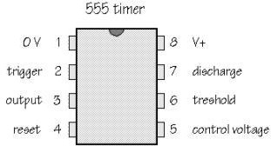

**Figure 1**: Pin configuration of the 555 timer IC.

# **Theory and Methodology:**

# Astable Multivibrator

# Two amplifying stages are connected in a positive feedback loop by two capacitive-resistive coupling networks to form an astable multivibrator. The frequency of the pulses and their duty cycle are dependent upon the RC network values. The astable multivibrator switches between two voltage levels using a continuous stream of rectangular off-on pulses. The duty cycle and frequency of the pulses are determined by the RC network settings.

**Figure 2:** 555 timer connected as an astable multivibrator

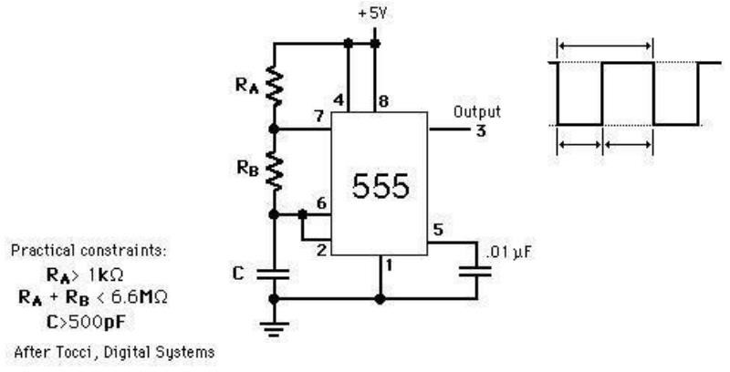

Fig-1: 555 timer connected as an astable multivibrator

Monostable Multivibrator**:** Monostable Multivibrators generate a single output pulse when they are externally activated and have only ONE stable state (thus the name "Mono"). Monostable Multivibrators only return to their initial, stable state after a certain amount of time, which is specified by the RC linked circuit's time constant. It can also be used to cause delays. A variety of sequential timing pulses can be formed by cascading numerous one-shots. You'll be able to time and sequence a variety of tasks using those pulses.

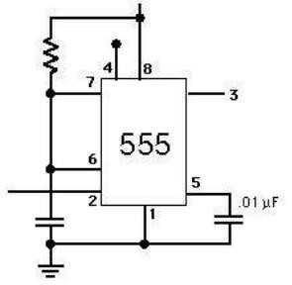

Fig-2: 555 timer connected as a monostable multivibrator

**Circuit Diagram/ Lab Work:**

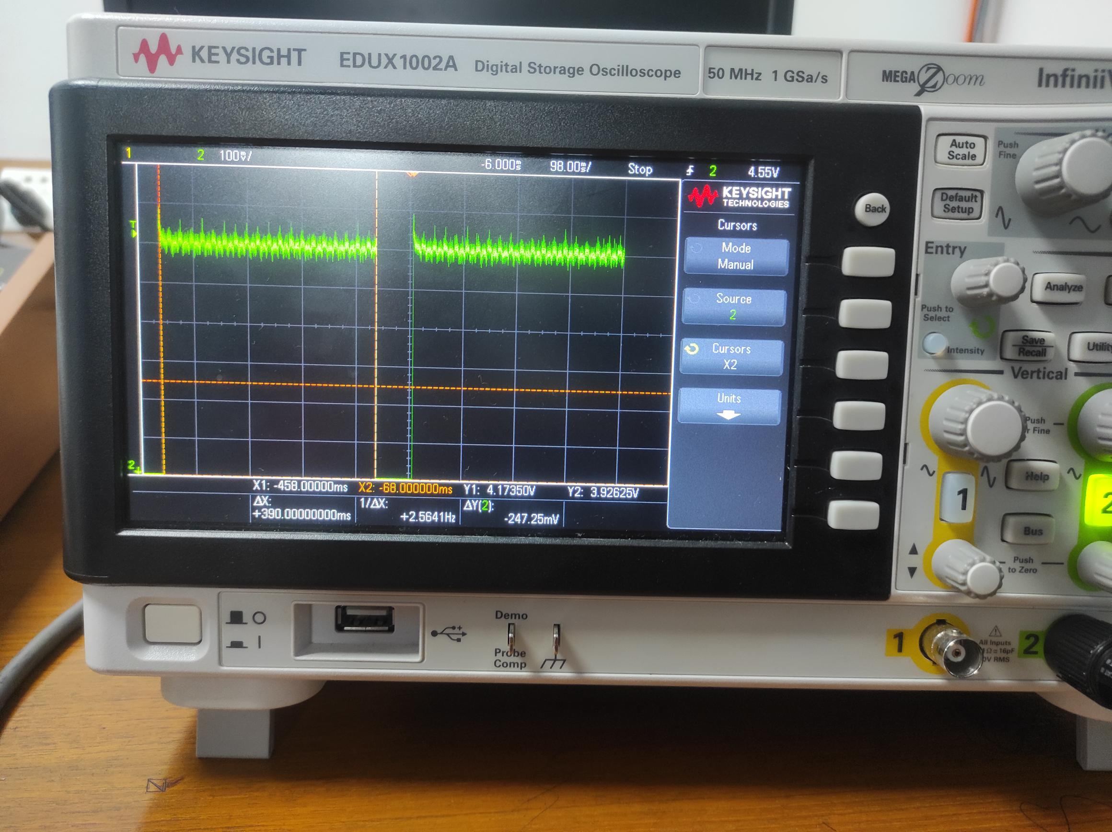

**Comparison of Theoretical and Practical values**

**Results & Simulations:**

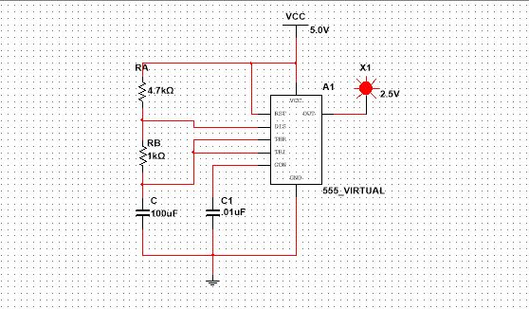

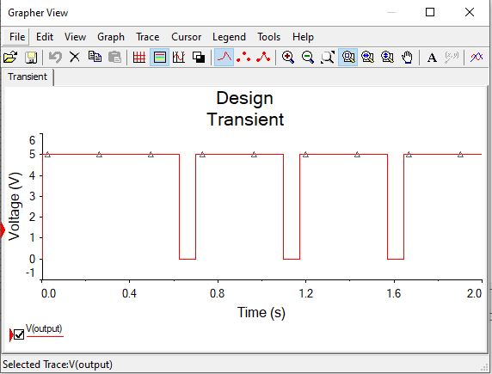

# **Report question answers**

# 1.What is 555 IC ?

# Ans:

# The 555 integrated circuit is a very reliable tool for creating precise time delays or oscillations. Different circuits can achieve the necessary outputs and mode of operation by utilizing external resistors and capacitors.

# 2.What are the two basic modes in which the 555 timer operates?

# Ans:

# The 555 timer basically operates in one of the two modes – either as monostable or as an astable multivibrator.

**3.** Design 555 ICastable multivibrator by using 555 timer IC and what is the free running frequency of the multivibrator?

# Given that RA=450 Ω;RB=0.5kΩ;C=1μF

# Ans:

# f=1.45(RA+2RB)C

# =1.45(0.45+2×0.5)×105×1×10−6

# =1.451.45×103 Hz

# =1000 Hz

# **Discussion and Conclusion:**

Astable multivibrator is unstable and changes their states in a continues manner. So, it can have both the states. It is internally triggered and does not have any stable state. Whereas in monostable multivibrator, one of the states is stable, but the other state is unstable. A trigger pulse causes the circuit to enter the unstable state. After entering the unstable state, the circuit will return to the stable state after a set time. The whole experiment was done practically in lab. In astable multivibrator, Duty cycle was found 98.3 seconds theoretically end 85.1 in practically. The frequency between theoretical value and practical below are also different. Point Summation of output high and low results at 0.40 seconds which is quite similar. To compare between theoretical and practical values, it is perceived that they are quite identical. Practical values are greater for every value. Needless to say, there is always a possibility of humane error while doing a lab practically. For monostable multivibrator, theoretical value practical value are not same. This also proves the fact that there is a possibility of error while taking the reading. But the values are quite similar. A better understanding of astable multivibrator and monostable multivibrator was achieved during this experiment.